

Press Release

BEAT

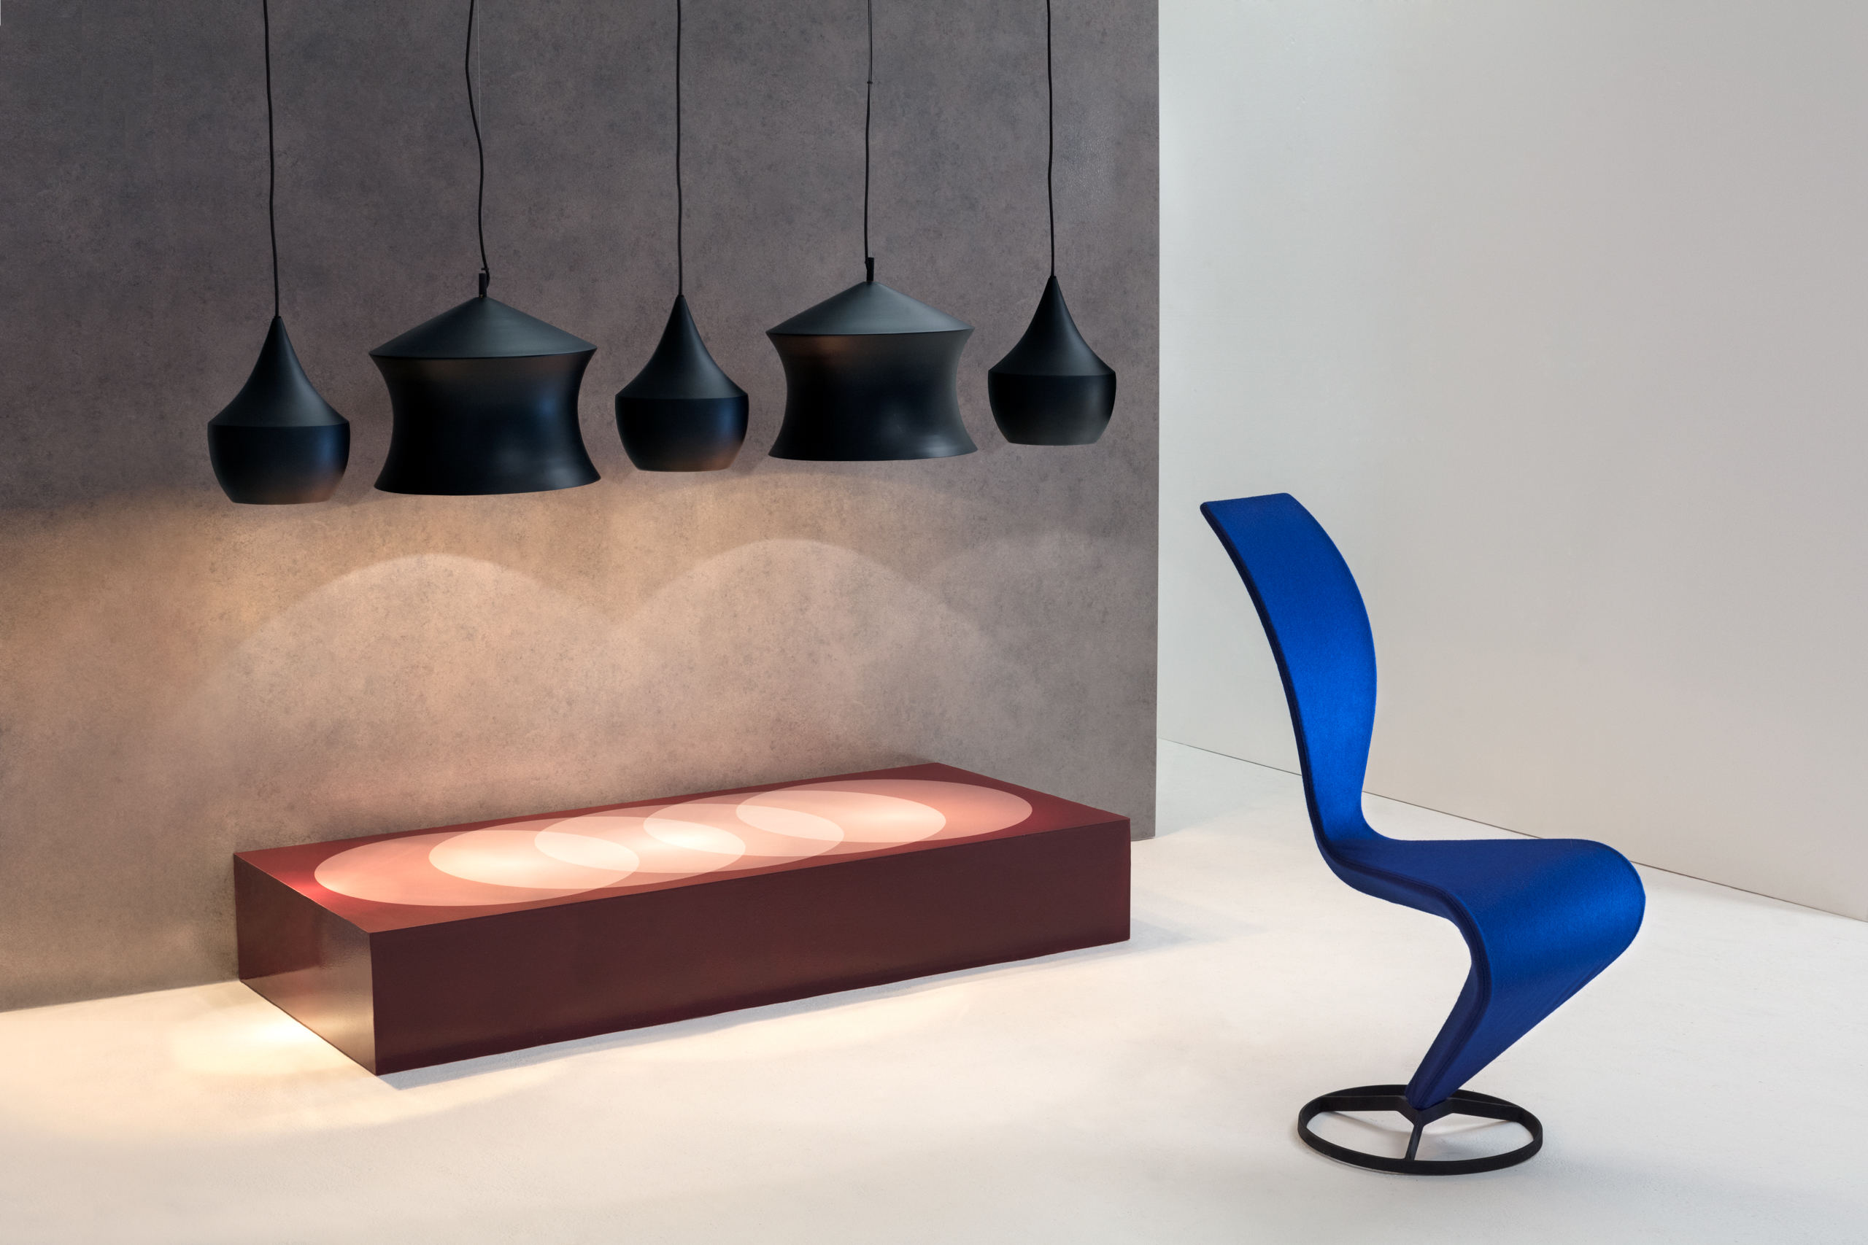
A series of lights in six distinctive pendant shapes. Inspired by the sculptural simplicity of traditional Indian water vessels and available in four finishes, all with a warm interior of beaten brass or silver plate.

The BEAT collection includes Stout, Flat, Wide, Fat, Tall and Waist pendants as well as Floor, Table and Wall lights. Available in Black, Brushed Brass, White and Grey.

About Tom Dixon: Established in 2002, Tom Dixon is a British product design brand. With a commitment to innovation and a mission to revive the British furniture industry, the brand is inspired by the nation’s unique heritage and produces extraordinary objects for everyday use.

For further information please visit our website tomdixon.net and contact our Press Office at press@tomdixon.net

