

Press Release

BELL

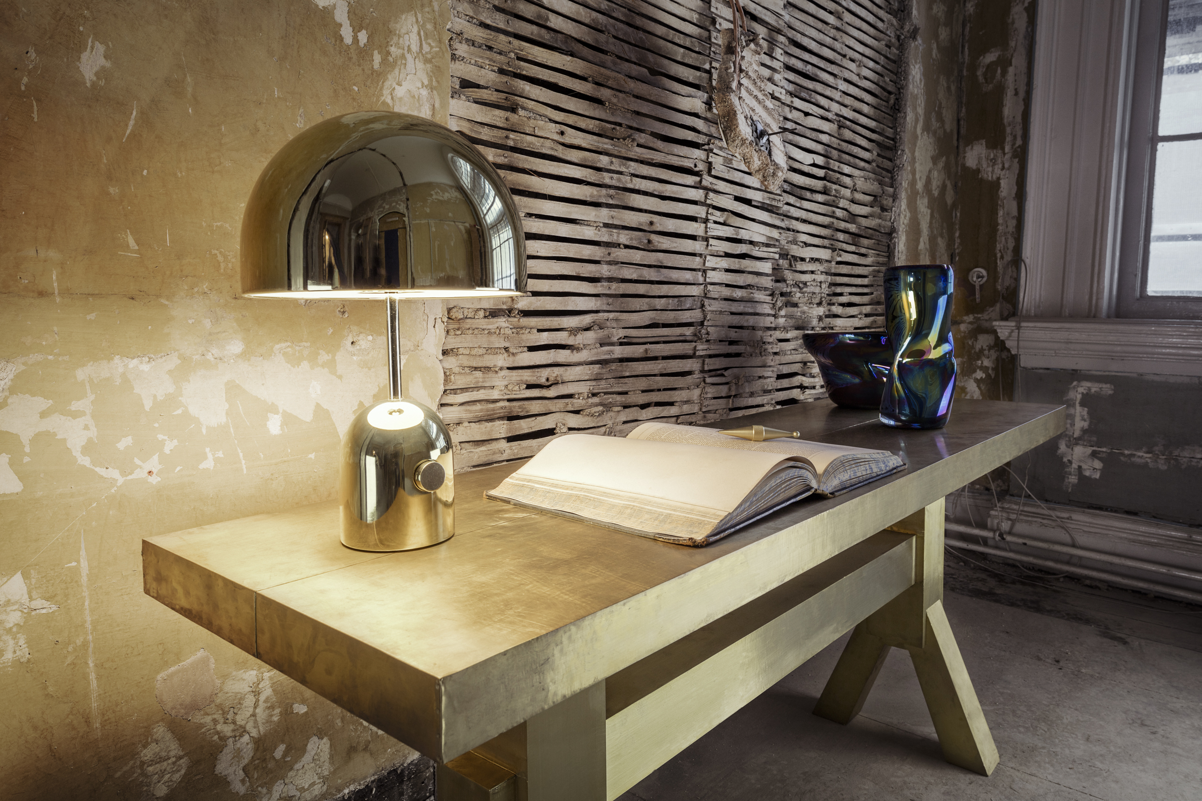
Formed from chrome-plated steel, Bell is an exercise in reductionism. The hyper polished reflective surface allows it to take on the tone and characteristics of its surroundings.

The BELL collection includes BELL Table Light available in brass, copper and chrome. And a Floor light in Chrome.

About Tom Dixon: Established in 2002, Tom Dixon is a British product design brand. With a commitment to innovation and a mission to revive the British furniture industry, the brand is inspired by the nation’s unique heritage and produces extraordinary objects for everyday use.

For further information please visit our website tomdixon.net and contact our Press Office at press@tomdixon.net

